Contents

SCRUM 3

Scrum method 3

Artifacts 3

Ceremonies 4

Scrum Workflow 4

AGILE- 5

Values 5

Principles 5

Summary 6

AGILE Vs Waterfall 6

Waterfall Planning 6

Original waterfall 6

Agile Manifesto 7

Summary 8

KANBAN 8

debos 10

Visual Studio 10

GitHub 10

Jenkins 10

Unit33-1.2

SCRUM-<https://www.youtube.com/watch?v=9TycLR0TqFA>

With the scrum method, the product owner allows the manufacturer to start the project with minimal planning, enough to get the project started with the earliest stages of the project’s procedure.

it is now potentially ready to deploy, this stage is then allocated [monitoring stage], awaiting the final overall review prior to completion.

The stage is known as a ‘Sprint’, each sprint is an element of the ongoing procedure of building a product or service.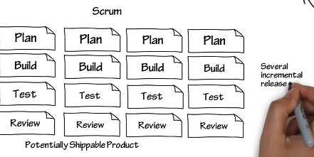

### Scrum method

The scrum method has three main roles,

* **Product Owner**-*the person who initiated the project*
* **Scrum Master**-*leader of the team*
* **Team-developers***, professionals, specialists, Kinetic operatives*

### Artifacts

There are three artifacts to scrum,

**Product Backlog**-*changes priority with sprints as they progress allowing for problems that have arisen during a sprints progress that could potentially affect the products end review, and neds to be adapted at an early stage, to ensure it does not reflect on later stages. Shape, polygon
*

**User Stories-** *a report or note that highlights ongoing problems whilst completing a sprint.*

**Burndown Chart-** *shows the progress of the individual sprints, heading toward zero and completion.*

### Ceremonies

There are three ceremonies of a scrum,

**Sprint Planning-** *a discussion on how the user stories effect the sprint.*

**Daily scrum-***brief meeting discussing the progress and foreseeable problems.*

**Sprint Review-***occurs at the end of the sprints/ project with the owner and finalises any improvements.*

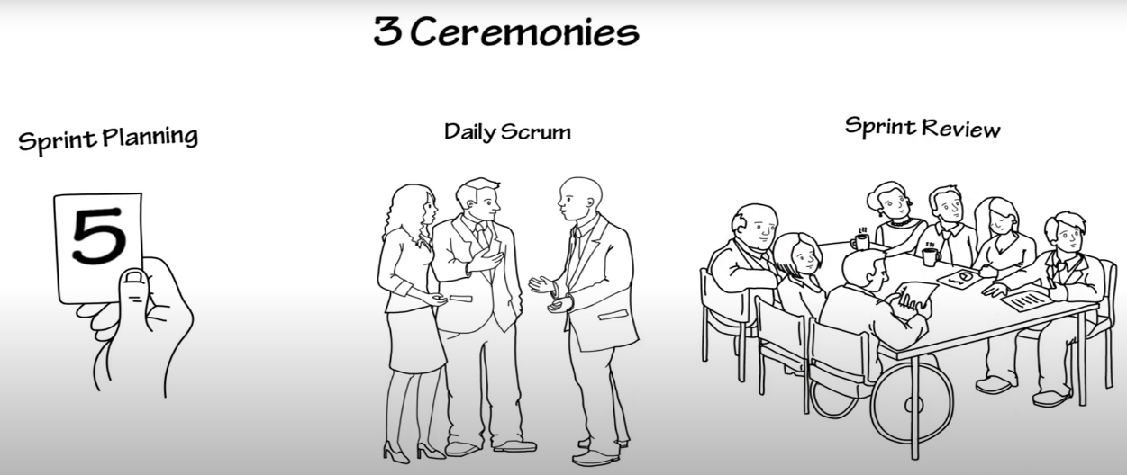

### Scrum Workflow

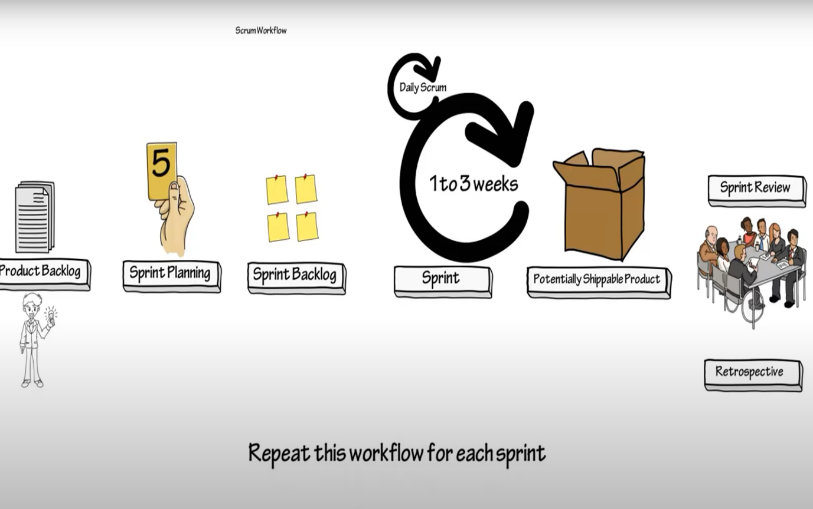

AGILE-<https://www.youtube.com/watch?v=Z9QbYZh1YXY>

### Values

When using agile as your development method, the values your team should prioritise are individuals and their input, the proven software applications required to build your project, talking with customers needs and wants, and responding to lessons learnt.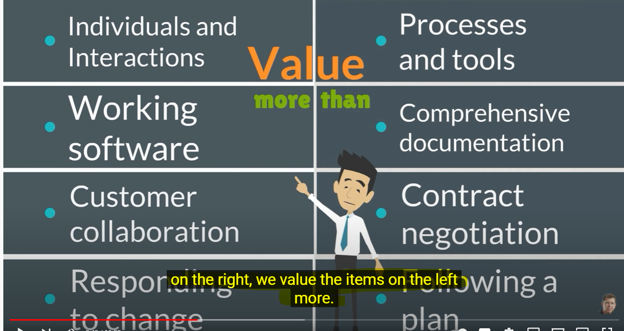

### Principles

The principles of the Agile method are designed to give the team the ability to realise good decisions and act upon them.

1. Continuous delivery of valuable software to the customer.
2. Ensure changes are an important part of securing a competitive product for the customer.
3. Delivering software within a shorter timescale, suppling a competitive product.
4. Businesses & developers must liaise throughout the project.
5. Give team members ownership and support of their individual roles in the process.
6. Encourage 121/team meetings, juxtaposed[1].
7. Working software is the primary measure of progress[2].
8. The process should enable sponsors & developers to maintain pace and progress.
9. Attention to technical and design, enhance agility ensuring progress.
10. Keep thing simple and maximise the production of the work.
11. Best designs, requirements, and layouts are built by self-organised teams working together.
12. During the progress, teams identify weaknesses & strengths, and adjust accordingly.

*Agile is a set of beliefs where team members can agree decisions in developing software.*

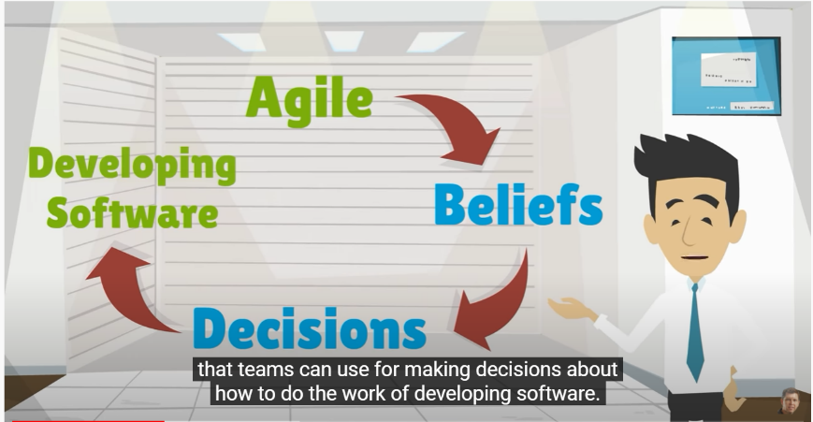

### Summary

Agile encourages product owners to continually liaise with the progress, debating changes, including customer input, as the team progresses, they are making decisions based on Agile values & principles.

Teams must follow their own path and not simply follow another’s successful process, as this is not necessarily compatible with your project requirements, once the team begins the project process, it might realise changing the development methodology, to Scrum or Kanban, depending on the team, project style the environment and the customer wants and needs.

Team building, relationships using the ideal software and deploying the best practices to suit the required process, are the agile method, enhanced by the teams/product owner/customer ongoing experience.

AGILE Vs Waterfall**-**<https://www.youtube.com/watch?v=5RocT_OdQcA>

### Waterfall Planning

If the project has been thoroughly pre-planned from Build to deploy, as the project progresses unforeseen problems can arise and therefore the planning of the budget and resources change, this leads to a loss of time and production.

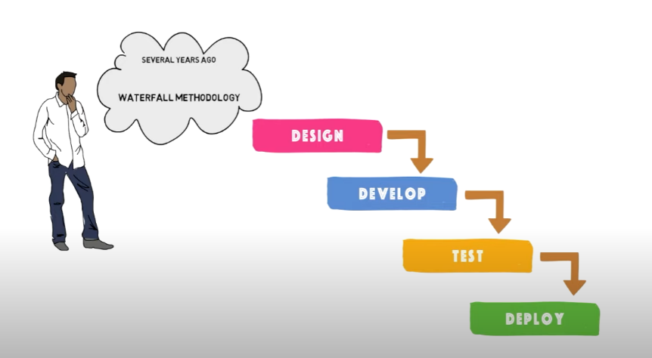

### Original waterfall

The early development method, using fixed stages to complete a project, working from planning down to deployment of the product.

Waterfall does not require customer involvement, meaning the original plan/ideas do not consider the customers changing and competitive requirements.[3] Because of its rigid structure, waterfall methodology means it can not easily adapt to changes or respond to unforeseen problems, or react to new ideas.

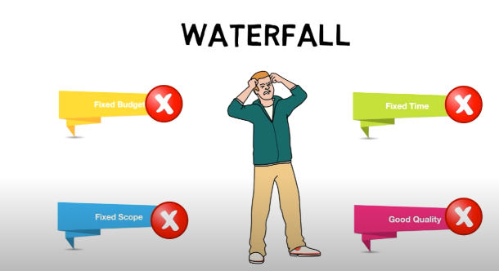

### Agile Manifesto

Agile’s manifesto has 4 values and 12 principles, the process stages are interlocked, easily adaptable because they are still active throughout the process.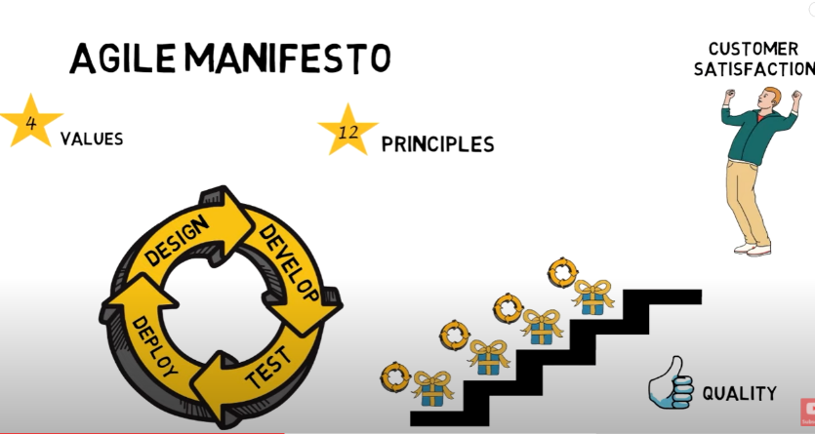

**Whereas waterfall is rigid, agile is flexible,**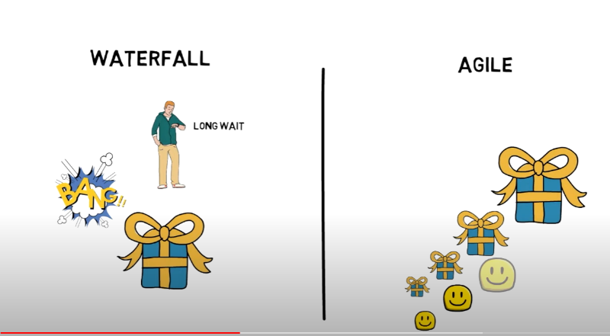

**Agile being flexible means it can deliver a customer wants and needs, whilst maintaining its products competitive balance in the markets.**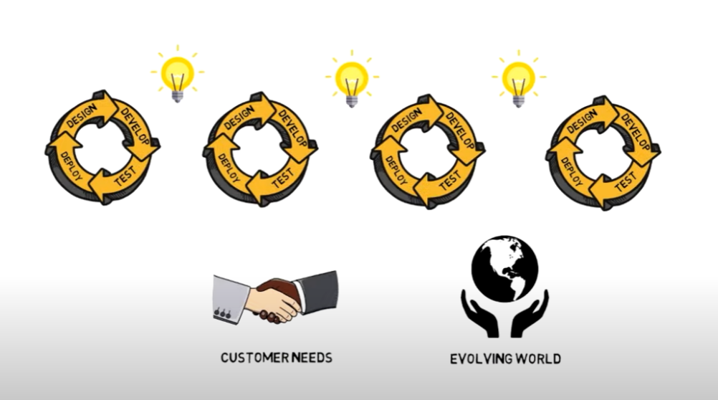

### Summary

Because waterfall method is using a rigid approach to its progress, a customer is not part of the ongoing process, the customer orders and receives the end product, at this stage if the customer is not satisfied with the product, the adaptions the developer needs to include can prove time consuming and costly and receiving negative feedback.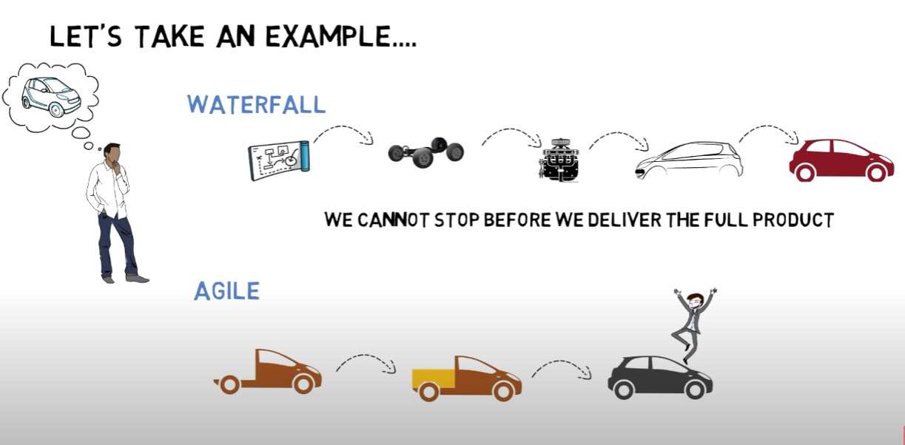

KANBAN**-**<https://www.youtube.com/watch?v=jf0tlbt9lx0>

Kanban is an efficient collaboration tool, helps managers and teams stay organized, adaptable across several industries, a Kanban board has three simple attributes,

* To Do
* In Progress
* Completed

This board highlights the workflows throughout the team progress. The product owner can be the business owner or a project manager, their role is to maintain a list of work items that are to be carried out during the progress, 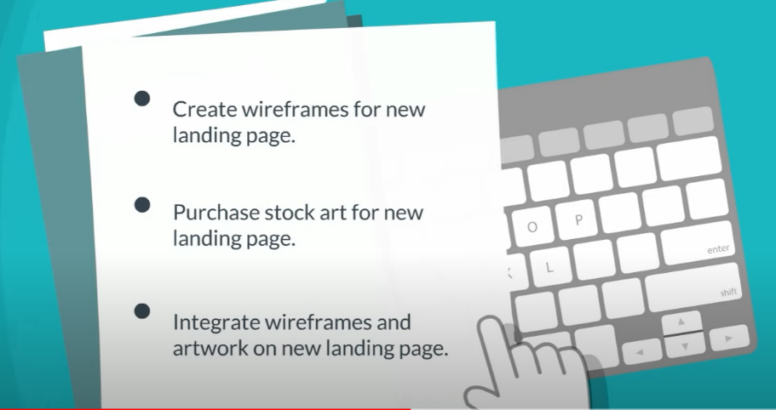

Represented on a board has tasks, subject to the user story attributes, it builds a sequence of tasks the team must be allocated for the progress to continue.

debos is **a tool to make these kinds of trivial tasks easier**. debos works using recipe files in YAML listing the actions you want to perform in your image sequentially and finally, choosing the output formats.27 Jun 2018

[Introducing debos, a versatile images generator (collabora.com)](https://www.collabora.com/news-and-blog/blog/2018/06/27/introducing-debos/#:~:text=debos%20is%20a%20tool%20to,finally%2C%20choosing%20the%20output%20formats.)

### Visual Studio

An integrated development environment, owned by Microsoft, used to develop computer programs, web pages for web sites, apps.

Users can edit, debug, and build code and then publish, includes compilers code completion tools, graphic design, and many other features to support developers in their work.

### GitHub

Provider of internet hosting for software, where you can store your files and share and give permissions, to allow others to collaborate online to improve each other’s work and knowledge.

### Jenkins

An open-source automatization server helps users to build test and deploy, by continuing to integrate delivery. Ensuring web pages work properly on different server platforms.

1. Face to face, eye to eye, meeting [relationship enhancing]
2. Developers can maintain pace through **Proven** good design software applications
3. Agile allows input from the customer during the build process ensuring the end deploy, is the product the customer requires to remain competitive in their environment.